https://ttpsc.com/en/pressroom/

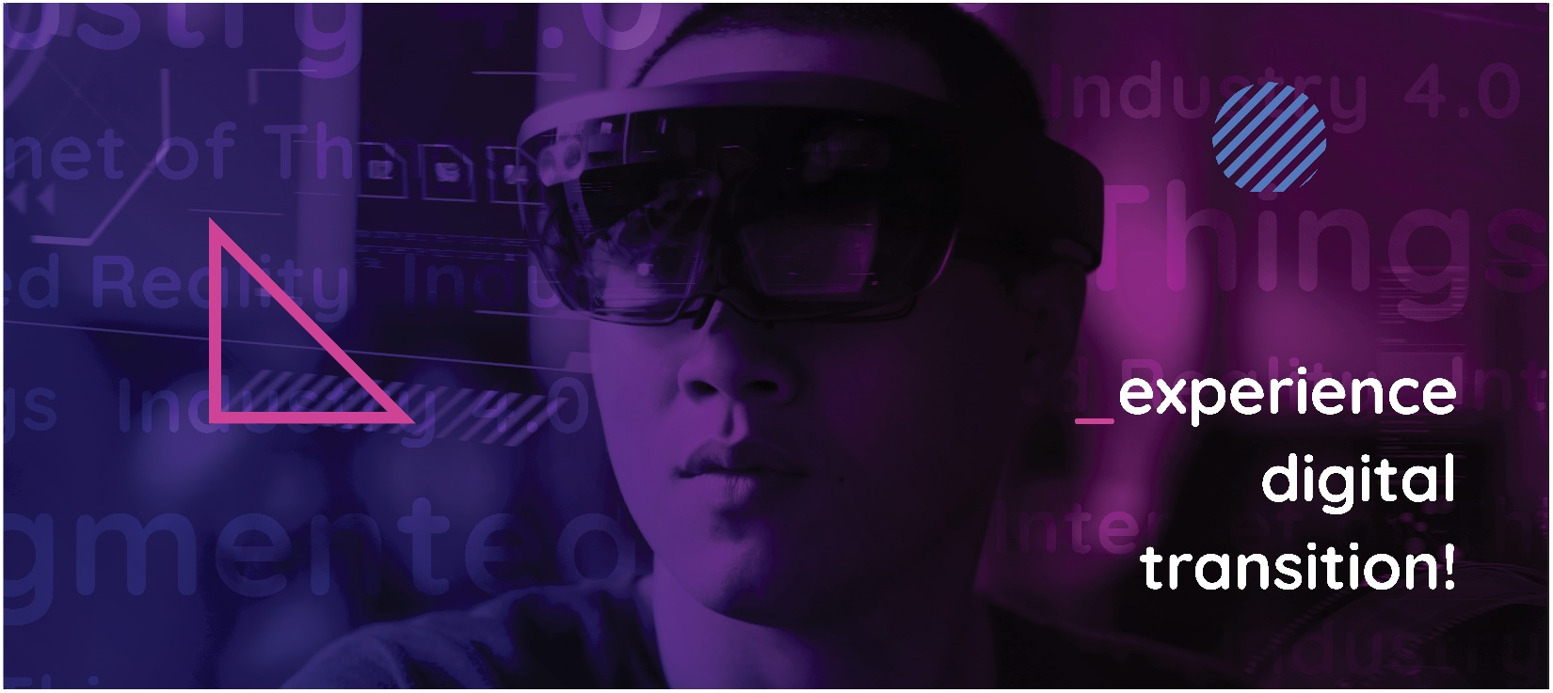

About Transition Technologies PSC

With more than 600 technology specialists in IoT, Cloud, Augmented Reality, Machine Learning, Enterprise PLM and other value chain technologies, TT PSC works with many of the world’s most familiar companies to create and implement solutions that improve the way products are designed, manufactured, operated, and maintained. Through 23 offices on 3 continents, TT PSC serves customers in the Capital Equipment, Energy, Pharmaceutical, Medical Device, Automotive, Consumer goods, Communications and High-Tech sectors. TT PSC is a partner of PTC, Inc. since 2005, and a long-term partner of many multinational corporations (including Microsoft, Google, Atlassian, Rockwell Automation, AWS, Azure, Synopsys, RealWear), supporting their strategies and business plans with leading technologies and business solutions.
TT PSC is a member of the Transition Technologies Group (TT). For more than 28 years the 2000+ Software Engineers, IT Architects and System Programmers of TT have been providing the world’s highest levels of technology solutions and services to customers in the continuous process and discrete manufacturing industry sectors.

